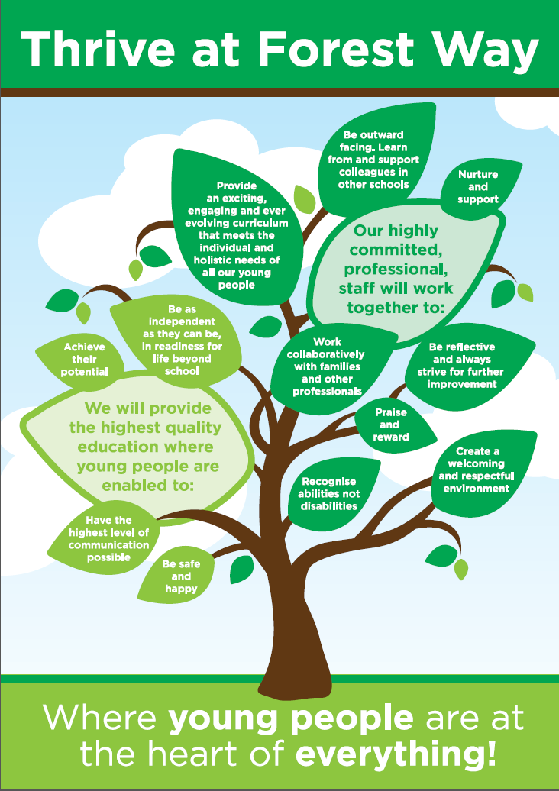

Application Form for both Teaching and Support staff
Post Applied For:
Personal Details
Surname: |  |  |  |  |  | Previous Name(s):
Forename(s): |  |  |  |  |  | Title:
Address:
Home No: |  |  |  |  |  | Mobile No:
Which number are you happy to be contacted on? Home No: YES / NO Mobile No: YES / NO
Email Address:
Teacher number (if applicable) |  |  |  |  |  |  | NI Number:
Present Employment
(or most recent)
Post Title: |  |  |  |  | Date Appointed:
Employers Name:
Employers
Address:
Type of School: |  |  |  |  |  | Age Range:
Subjects(s) Taught: |  |  |  |  |  | No. On Roll:
Salary on Leaving: |  |  |  |  |  | Allowances:
Date Left (if applicable): |  |  |  |  |  | Reason for Leaving:
References
(References MUST be from your current or most recent employer)
Name: |  |  |  | Name:
Job Title: |  |  |  | Job Title:
Address: |  |  |  | Address:
Contact Number |  |  |  | Contact Number:
Email Address |  |  |  | Email Address:
Relationship to Applicant: |  |  |  | Relationship to Applicant:
Character references will not be accepted , referees MUST only be those who can comment authoritatively on your work. REFERENCES WILL BE SOURCED PRIOR TO INTERVIEW FROM YOUR LAST TWO EMPLOYERS

Previous Employment – Teaching & Non-Teaching Posts - starting with the most recent
(Please add more lines if required)
Dates: |  | Employer’s Name & Address: | Post: |  |  | Salary (inc allowances): |  | Reason for leaving:
From: | To:
Education
Dates: |  | Establishment Name & Address: |  |  |  | Qualifications: |  | Grade:
From: | To:
Membership of Professional Organisations
Dates of Membership: |  | Professional Body / Organisation: |  |  | Membership Level:  Grade:  Duration:
From | To
Relevant Professional Development
(in the last 5 years)
Dates: |  | Organising Body: |  | Subject: |  |  | Grade: |  | Duration:
From | To
Break in Previous Employment History
(if applicable)
Dates: |  | Reason for break:
From | To
Summary of Experience, Skills, Knowledge & Competencies
Please let us have as much information as possible outlining your suitability for the role by referring to the person specification and providing evidence of impact and outcomes. (maximum of 2 pages):

Summary of Experience, Skills, Knowledge & Competencies (continued)
Continue on this page……..

Additional Information – Maximum of 500 Words (if required)
Please detail any further information you feel is relevant to your application that has not already been covered on this application:
Interview Arrangements
Please indicate below any dates you would not be available for interview:
Disability / Health Conditions
The Equality Act 2010 defines disability as ‘A physical or mental impairment which has a substantial and long-term adverse effect on the ability to carry out normal day-to-day activities.’

Do you consider yourself to be disabled? Yes/No
Please indicate below if you require any reasonable adjustments, due to a disability or health condition, to enable an interview, or which you wish us to take into account when considering your application?

Data Protection Act
The information you supply when requesting a job pack will be held for monitoring and evaluation purposes and in connection with any future contact. This information will be kept for a maximum of 18 months from last contact. When you sign and return this form you are giving your permission to process and hold the information you have supplied on it, including any information you consider to be personal and sensitive, if your application is unsuccessful, the form will be held for up to 6 months and then destroyed.
Applicant Declaration
I confirm that the statements in this application are true, correct and accurate and that I have not omitted any facts which may have any bearing on my application. I understand that falsification of qualifications or any other information may lead to the withdrawal of any offer of employment, or dismissal where employment has already commenced. By signing this form, I agree to the School/College/Academy using this information to consult any third parties or external organisations for the purposes of confirming and/or clarifying such information.

I understand that if I don’t tell you about any relationships with employees or governors at the School/College/Academy and this is discovered after appointment, I could be dismissed.

The amendments to the Exceptions Order 1975 (2013 & 2020) provide that certain spent convictions and cautions are ‘protected’ and are not subject to disclosure to employers and cannot be taken into account. Guidance and criteria on the filtering of these cautions and convictions can be found on the Ministry of Justice website.

Should you be shortlisted for the position, you will be required to complete a criminal records self-declaration form in order to provide any information about any unspent and unprotected criminal records that you may have.

I understand that if I am shortlisted for the position and do not tell you about any relevant unspent criminal convictions including adult cautions, reprimands, warnings or that I am under investigation or have pending prosecutions and this is discovered after appointment, I could be dismissed without notice.

I can produce the original documents of my qualifications at interview.

I understand that any canvassing, directly or indirectly, will be a disqualification.

I understand I MUST provide documents proving eligibility to work in the UK, prior to confirmation of appointment.

I am prepared to undergo a medical examination, prior to any appointment.

Signature: | Date:

Equal Opportunities Monitoring Section (to be removed prior to shortlisting)
This School / College / Academy want to meet the aims and commitments set out in its equality policy. This includes not discriminating under the Equality Act 2010, and building an accurate picture of the make-up of the workforce in encouraging equality and diversity. The School / College / Academy needs your help and co-operation to enable it to do this, but filling in this form is voluntary. The information you provide will stay confidential, and be stored securely.
1) How would you describe your ethnicity?
 | a) White |  | b) Mixed |  | c) Asian & British Asian
 | British |  | White & Black Caribbean |  | Indian
 | Irish |  | White & Black African |  | Pakistani
 |  |  | White & Asian |  | Bangladeshi
 | Any other White background* |  | Any other mixed background* |  | Any other Asian background*
 | * please state below: |  | * please state below: |  | * please state below:
 | d) Black or Black British |  | e) Chinese of Other Ethnic Group |  | f) Gypsy / Traveller
 | Caribbean |  | Chinese |  | Irish Traveller
 | African |  |  |  | Romany Gypsy
 | Any other Black background* |  | Any other Ethnic Group* |  | Any other Asian background*
 | * please state below: |  | * please state below: |  | * please state below:
 | Prefer not to state
2) My sex is:
 | Male |  | Female |  | Prefer not to state
3) My date of birth is: |  |  |  |  | Prefer not to state
4) The Equality Act 2010 defines disability as “‘A physical or mental impairment which has a substantial and long term adverse effect on the ability to carry out normal day-to-day activities”
I consider myself to be:
 | Disabled |  | Non-Disabled |  | Prefer not to state
5) My religion is:
 | Buddhist |  | Christian (all denominations) |  | Hindu
 | Jewish |  | Muslim |  | Sikh
 | None |  | Prefer not to state |  | Other *
 |  |  |  |  | * please state below:
6) My sexual orientation is:
 | Bi-sexual |  | Gay |  | Lesbian
 | Heterosexual |  | Transgender |  | Prefer not to state
 |  |  |  |  | Other *
 |  |  |  |  | * please state below:
7) My nationality is:
 | Short listed |  | Interviewed |  | Appointed

